**Mission Space Lab Phase 4 report outline**

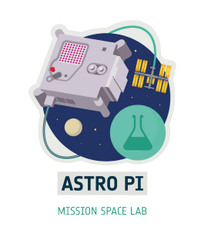

Team name: Trivials

Chosen theme: Life on Earth

Organisation name: Colégio Júlio Dinis

Country: Portugal

|  |
| --- |
| Layout information:   * Your report must fit on no more than 4 pages of A4. Reports that exceed this length won’t be accepted. * Each section should have a title, as shown in this outline. * Please use the font ‘Verdana’ with the titles in font 14 and the main text in size 11. * All images and graphics should have a concise caption underneath the image. * Once your report is finished, save it as a PDF for submission. * Please avoid writing any personal data, such as student names or social media accounts in this report. |

1. Introduction

In this section you should introduce your investigation. Explain what your team aimed to investigate, why this is interesting and what you expected to find.

This section is limited to 200 words.

This experiment utilizes the Astro Pi's Near Infrared camera aboard the International Space Station (ISS) to assess and monitor various aspects of Earth's environment. The primary focus is on analysing forest cover using the Normalized Difference Vegetation Index (NDVI). By capturing imagery from space, we aim to determine the percentage of land covered by forests and vegetation, as well as evaluate the impact of recent forest fires on foliage density over large areas of the planet. Furthermore, we seek to identify variations in vegetation coverage surrounding urban areas, comparing these findings to previous surveys conducted by NOAA satellites to understand the effects of urbanization on vegetation.

In situations where land vegetation data is not available or inconclusive, our experiment also includes monitoring the size of garbage patches in the ocean. This is accomplished by measuring the presence of algae on the water's surface. By combining these different areas of analysis, we hope to gain insights into the state of Earth's ecosystems and better understand the impact of human activities on the environment. The results of this experiment can contribute to informed decision-making for conservation efforts, urban planning, and addressing environmental challenges on a global scale.

2. Method

In this section you should explain what your team decided to measure, how you collected the data you needed and how you decided to analyse your data. You should explain any advantages or disadvantages of the methods that you chose.

Some things to think about are:

* What sensors did you use, and why?
* What type of data was collected? Images, text files etc.
* Was any of the data processed on Earth?
* If you used machine learning, did you use the Coral dongle to do this during your data collection, or during analysis when you had received your data?
* (Optional) If you are submitting a link to a GitHub repository with your report, briefly explain the additional programs/code you have written to help analyse your experiment data.

This section is limited to 200 words.

This experiment utilizes the Astro Pi's Near Infrared camera aboard the ISS to process images and calculate the Normalized Difference Vegetation Index (NDVI). By enhancing contrast, calculating NDVI, and applying colour mapping, it enables the analysis and visualization of vegetation cover and density.

The code utilizes the Astro Pi's Near Infrared camera aboard the ISS to process images and analyse vegetation cover using the Normalized Difference Vegetation Index (NDVI). The process starts by reading an image and applying contrast stretching to enhance subtle changes. This is followed by calculating the NDVI, which measures the health and density of vegetation based on the reflectance of red and infrared radiation. The NDVI image is then further contrast-stretched to improve visibility.

To visualize the results, a colour map is applied to the NDVI image. The colour mapping enhances the representation of vegetation by assigning different colours to different NDVI values. This colour-mapped image provides a visual depiction of vegetation density.

Additionally, there is a function to process multiple images in a specified directory, ensuring each image is processed only once and saving the processed images with appropriate filenames.

Thus, all the data was processed automatically during the experiment run-time.

3. Experiment results

In this section you should present your results. We encourage teams to use pictures, charts and figures where they are helpful to explain your findings. This section is limited to 300 words.

While with this experiment we primarily hoped to be able to identify areas affected by forest fires, the data obtained didn’t allow for any conclusion in this regard, as many of the images were either taken during nighttime or were obstructed by clouds, and those where a clear view was obtained didn’t show any areas recently affected by wildfires.

Some images showed a clear difference in NDVI values between urban centres and the surrounding areas, with cities like New York and Bissau presenting different changes in NDVI relative to the surrounding environment, as can be seen below.

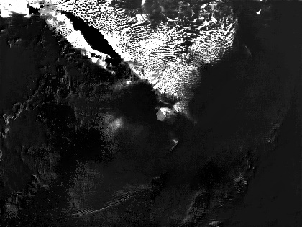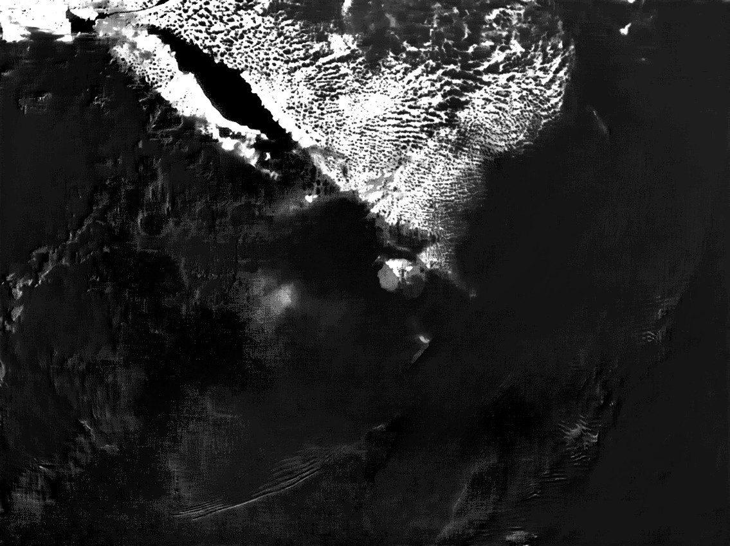

Figure 1 - NDVI map of New York City and surrounding area. Urban centre highlighted.

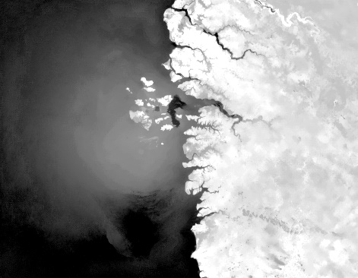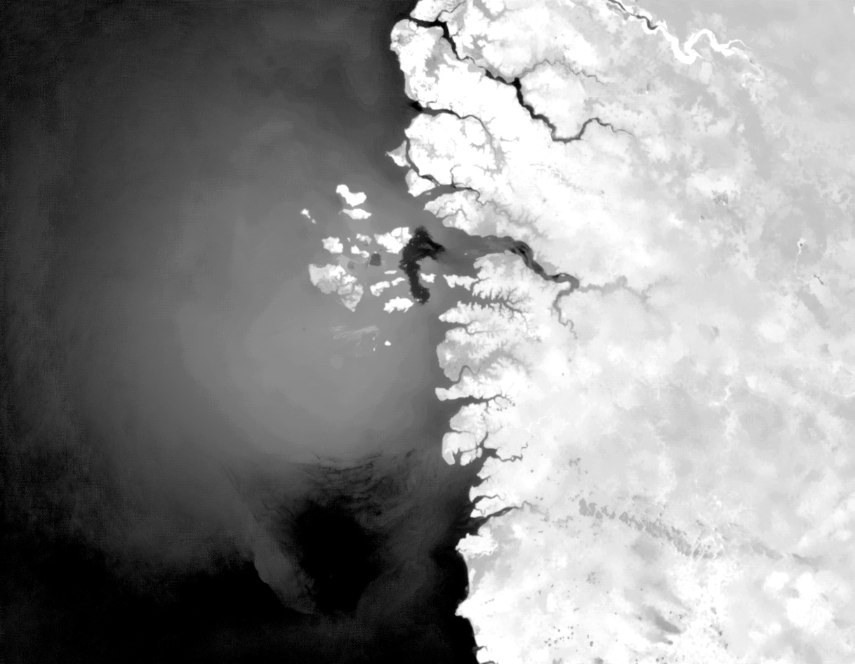

Figure 2 - NDVI map of Bissau and surrounding area. Urban centre highlighted.

Unfortunately, though we meant to compare NDVI values of urban areas with the past, relying on NOAA’s NDVI surveys (available at <https://www.ncei.noaa.gov/thredds/catalog/cdr/ndvi/catalog.html> as of 08/06/2023) to do so, the difference in resolution of our mapping and the existing NOAA data made such a comparison impossible. Using that data, we were still able to identify an increase in vegetation density in most of the Northeastern United States, as can be seen in the following pictures, which show NDVI values for the region from 1983 to 2018, with 5-year intervals between images (data referring to the same day of each year – 24th of April). In these images we can also see that despite the increase in overall vegetation in the area represented, New York City (marked in blue) remains with a low vegetation index due to its high degree urbanisation.

Figure 3 - NDVI maps of the Northeastern United States between 1983 and 1998 (5-year intervals).

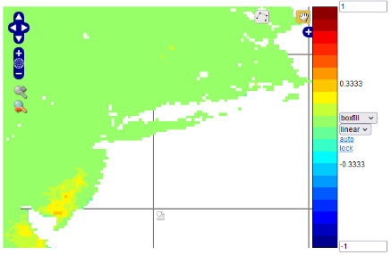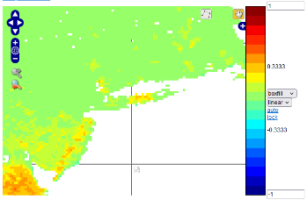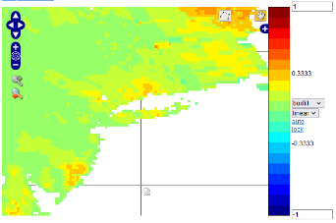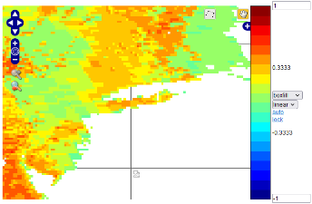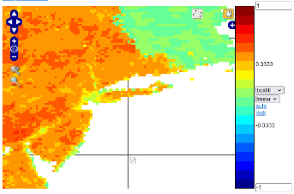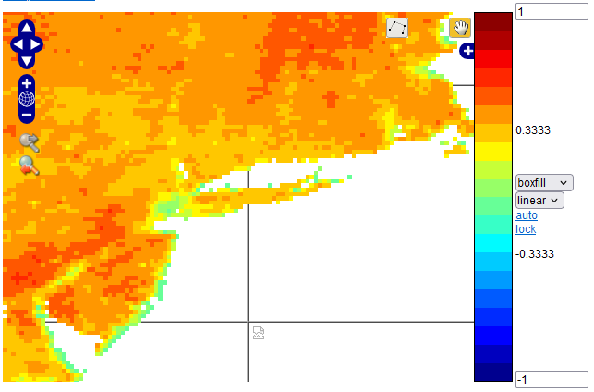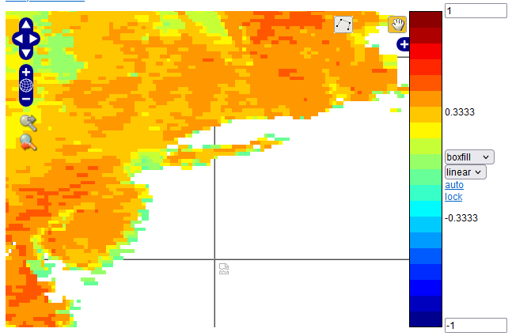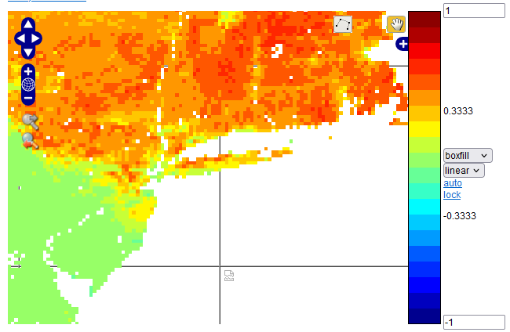

Figure 4 - NDVI maps of the Northeastern United States between 2003 and 2018 (5-year intervals).

4. Learnings

This is a new section this year. Please tell us about your experience working as a team on Mission Space Lab. This shouldn’t just be limited to skills such as coding, using the hardware and analysis techniques (although we would love to hear about this too!). For example:

* How did you plan and organise your work as a team?
* What challenges did you experience and how did you overcome them?
* What did you learn?
* What would you do differently next time?

This section is limited to 200 words.

This project presented many challenges

5. Conclusion

Don’t leave writing this section until the last minute — it is the most important! This is the final section that judges will read and should bring everything from your previous sections together. It is an opportunity for the team to share their reflections on their experience, their experiment design and results, and conclude on their findings. Did you find out what you were expecting? If not, why not? If your experiment did not produce any valid results, explain what you think went wrong and what you would do differently next time. This is still a valid finding.

This section is limited to 200 words.